LAB MID-TERM PERPARTION
DIGITAL IMAGE PROCEESING
Experiment # 01
Introduction to Python and Basics Concepts
PROGRAM#1:
In this example we implement and run the code of Assigning single value to multiple variables in python.
CODE:
x = y = z = 50
print (x)
print (y)
print (z)
OUTPUT:
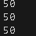
PROGRAM#2:
In this example we implement and run the code of Assigning multiple values to multiple variables in python.
CODE:
a,b,c=5,10,15
print (a)
print (b)
print (c)
OUTPUT:
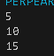
PROGRAM#3:
In this example we implement and run the code of Python Data Types in python.
CODE:
a=10
b="Hi python"
c=10.5
print(type(a))
print(type(b))
print(type(c))
OUTPUT:
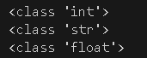
PROGRAM#4:
Write a Python code to solve the quadratic equation. (hint: import cmath library and use cmath.sqrt for this question)
CODE:
import cmath
def solve_quadratic(a,b,c):
discriminat=(b**2)-(4*a*c)
sol1=(-b+cmath.sqrt(discriminat))/(2*a)
sol2=(-b-cmath.sqrt(discriminat))/(2*a)
return sol1,sol2
a=int(input("Enter coefficient a:"))
b=int(input("Enter coefficient b:"))
c=int(input("Enter coefficient c:"))
solution1,solution2=solve_quadratic(a,b,c)
print(f"The solutions are{solution1}and{solution2}")
OUTPUT:
PROGRAM#5:
Write a Python code that implements basic calculator functioning (+, -, *, /) for user provided data of below mentioned data types.
a. int
b. float
CODE:
def add(x,y):
return x + y
def subtract(x,y):
return x - y
def multiply(x,y):
return x * y
def divide(x,y):
if y == 0:
return "Error: Division by zero is not allowed"
return x / y
def calculator():
try:
num1 = float(input("Enter first number: "))
num2 = float(input("Enter second number: "))
print("Select operation:")
print("1. Addition")
print("2. Subtraction")
print("3. Multiplication")
print("4. Division")
choice = int(input("Enter your choice (1/2/3/4): "))
if choice == 1:
print(f"{num1}+{num2}={add(num1, num2)}")
elif choice == 2:
print(f"{num1}-{num2}={subtract(num1, num2)}")
elif choice == 3:
print(f"{num1}*{num2}={multiply(num1, num2)}")
elif choice ==4:
print(f"{num1}/{num2}={divide(num1, num2)}")
else:
print("Invalid choice. Please try again.")
except ValueError:
print("Invalid input. Please enter a valid number.")
calculator()
OUTPUT:
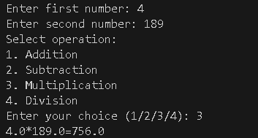
Experiment # 02
Introduction to OpenCV Library w.r.t. Image Processing Basic Commands
PROGRAM#1:
Now create a generic code that creates a border around any landscape image as shown below. The length of right and left borders must be 10% of the original horizontal length of the image. The length of upper and lower border must be such that the image now have same number of rows as columns. Save the image.
CODE:
import cv2
import matplotlib.pyplot as plt
image_path = ('apple.jpg')
image = cv2.imread(image_path)
image_rgb = cv2.cvtColor(image, cv2.COLOR_BGR2RGB) # Convert BGR to RGB for Matplotlib
plt.figure(figsize=(10, 10))
plt.subplot(3, 2, 1)
plt.imshow(image_rgb)
plt.title("Original Image")
plt.axis('off')
gray_image = cv2.cvtColor(image, cv2.COLOR_BGR2GRAY)
plt.subplot(3, 2, 2)
plt.imshow(gray_image, cmap='gray')
plt.title("Grayscale Image")
plt.axis('off')
blurred_image = cv2.GaussianBlur(gray_image, (7, 7), 0)
edges = cv2.Canny(blurred_image, 50, 150)
plt.subplot(3, 2, 3)
plt.imshow(edges, cmap='gray')
plt.title("Edge Detection")
plt.axis('off')
resized_image = cv2.resize(image, (100, 100)) # Resize to 100x100 pixels
cropped_image = image[30:180, 30:180] # Crop a section (adjust values as needed)
cropped_rgb = cv2.cvtColor(cropped_image, cv2.COLOR_BGR2RGB) # Convert for display
plt.subplot(3, 2, 4)
plt.imshow(cropped_rgb)
plt.title("Cropped Image")
plt.axis('off')
contours, _ = cv2.findContours(edges, cv2.RETR_EXTERNAL, cv2.CHAIN_APPROX_SIMPLE)
detected_image = image.copy()
cv2.drawContours(detected_image, contours, -1, (0, 255, 0), 3) # Draw contours in green
detected_rgb = cv2.cvtColor(detected_image, cv2.COLOR_BGR2RGB) # Convert for display
plt.subplot(3, 2, 5)
plt.imshow(detected_rgb)
plt.title("Object Detection (Contours)")
plt.axis('off')
# Display all results
plt.tight_layout()
plt.show()
OUTPUT:
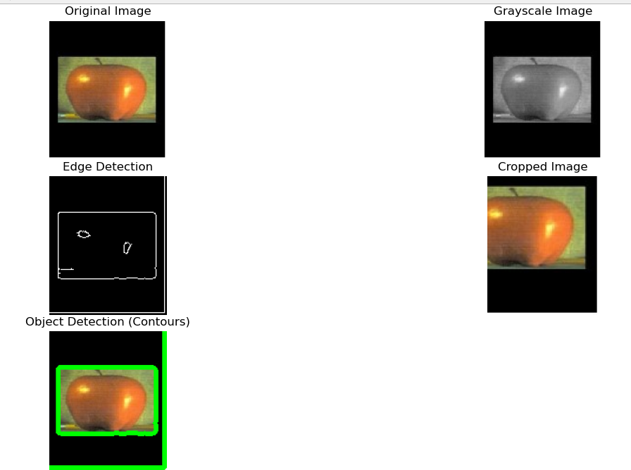
PROGRAM#2:
Using the following formula f (i, j) = sin (2 π f (i + j)) where i are j indices of a pixel, draw an image with different frequencies (input from user).
Experiment # 02
Introduction to OpenCV Library w.r.t. Image Processing Basic Commands
TASK#1:
Now create a generic code that creates a border around any landscape image as shown below. The length of right and left borders must be 10% of the original horizontal length of the image. The length of upper and lower border must be such that the image now have same number of rows as columns. Save the image.
CODE:
import cv2
import matplotlib.pyplot as plt
image_path = ('apple.jpg')
image = cv2.imread(image_path)
image_rgb = cv2.cvtColor(image, cv2.COLOR_BGR2RGB) # Convert BGR to RGB for Matplotlib
plt.figure(figsize=(10, 10))
plt.subplot(3, 2, 1)
plt.imshow(image_rgb)
plt.title("Original Image")
plt.axis('off')
gray_image = cv2.cvtColor(image, cv2.COLOR_BGR2GRAY)
plt.subplot(3, 2, 2)
plt.imshow(gray_image, cmap='gray')
plt.title("Grayscale Image")
plt.axis('off')
blurred_image = cv2.GaussianBlur(gray_image, (7, 7), 0)
edges = cv2.Canny(blurred_image, 50, 150)
plt.subplot(3, 2, 3)
plt.imshow(edges, cmap='gray')
plt.title("Edge Detection")
plt.axis('off')
resized_image = cv2.resize(image, (100, 100)) # Resize to 100x100 pixels
cropped_image = image[30:180, 30:180] # Crop a section (adjust values as needed)
cropped_rgb = cv2.cvtColor(cropped_image, cv2.COLOR_BGR2RGB) # Convert for display
plt.subplot(3, 2, 4)
plt.imshow(cropped_rgb)
plt.title("Cropped Image")
plt.axis('off')
contours, _ = cv2.findContours(edges, cv2.RETR_EXTERNAL, cv2.CHAIN_APPROX_SIMPLE)
detected_image = image.copy()
cv2.drawContours(detected_image, contours, -1, (0, 255, 0), 3) # Draw contours in green
detected_rgb = cv2.cvtColor(detected_image, cv2.COLOR_BGR2RGB) # Convert for display
plt.subplot(3, 2, 5)
plt.imshow(detected_rgb)
plt.title("Object Detection (Contours)")
plt.axis('off')
# Display all results
plt.tight_layout()
plt.show()
OUTPUT:
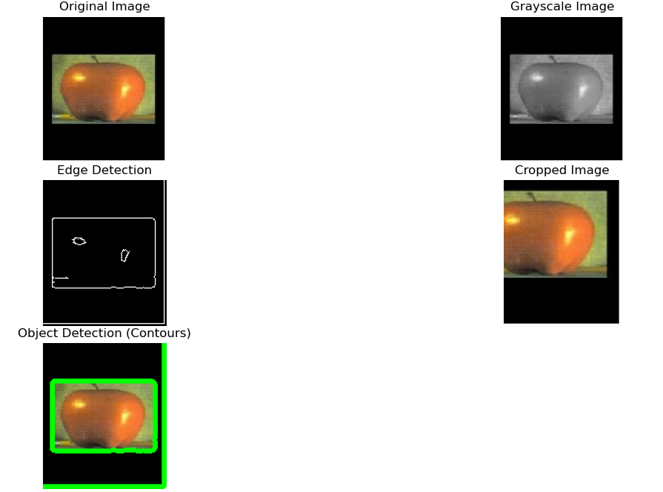
TASK#2:
Using the following formula f (i, j) = sin (2 π f (i + j)) where i are j indices of a pixel, draw an image with different frequencies (input from user).
CODE:
import cv2
import numpy as np
import matplotlib.pyplot as plt
# Function to generate the image with sine wave pattern
def generate_sine_wave(frequency, size=256):
image = np.zeros((size, size))
for i in range(size):
for j in range(size):
image[i][j] = np.sin(2 * np.pi * frequency * j / size)
return image
# Function to display the images with different frequencies
def plot_images(frequencies, size=256):
plt.figure(figsize=(15, 5))
for idx, freq in enumerate(frequencies):
plt.subplot(1, len(frequencies), idx + 1)
image = generate_sine_wave(freq, size)
plt.imshow(image, cmap='gray', extent=(0, size, 0, size))
plt.title(f"Frequency = {freq}")
plt.axis('off')
plt.show()
# Ask user for frequencies
frequencies = [float(x) for x in input("Enter frequencies separated by spaces: ").split()]
# Generate and display the images
plot_images(frequencies)
OUTPUT:
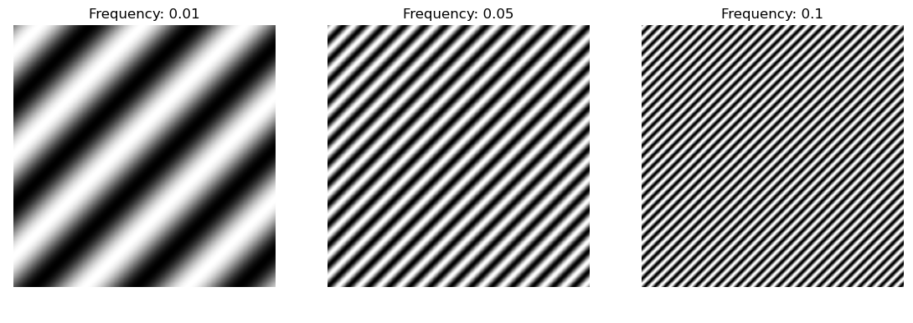
TASK#3:
Write Python functions that can create the images given below. Code them in such so that the size of the image itself are entered by the user.
CODE:
from PIL import Image, ImageDraw
import math
def create_image1(size):
img = Image.new('RGB', (size, size), (255, 255, 255))
draw = ImageDraw.Draw(img)
draw.rectangle([(0, 0), (size-1, size-1)], outline=(0, 0, 0))
img.save('image1.png')
def create_image2(size):
side_length = size // 2
img = Image.new('RGB', (size, size), (0, 0, 0))
draw = ImageDraw.Draw(img)
draw.rectangle([(side_length//2, side_length//2), (size-
side_length//2-1, size-side_length//2-1)], fill=(255, 255, 255))

img.save('image2.png')
size = int(input("Enter the size of the image: "))
create_image1(size)
create_image2(size)
OUTPUT:
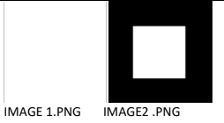
Experiment # 03
Implementation of Connected Component Analysis
TASK#1:
Connected Component Analysis or Labelling enables us to detect different objects from a binary image. Once different objects have been detected, we can perform a number of operations on them: from counting the number of total objects to counting the number of objects that are similar, from finding out the biggest object of the bunch to finding out the smallest and from finding out the closest pair of objects to finding out the farthest etc.
CODE:
import cv2
import numpy as np
# Load the uploaded image
image_path = '/mnt/data/Screenshot 2024-10-10 211014.jpg'
image = cv2.imread(image_path)
# Convert the image to grayscale
gray_image = cv2.cvtColor(image, cv2.COLOR_BGR2GRAY)
# Apply a binary threshold to the image (convert to black & white)
ret, binary_image = cv2.threshold(gray_image, 127, 255,
cv2.THRESH_BINARY)
# Find contours (connected components)
contours, hierarchy = cv2.findContours(binary_image,
cv2.RETR_TREE, cv2.CHAIN_APPROX_SIMPLE)
# Create a blank image with the same shape as the original to draw
contours with random colors
image_with_colored_contours = np.zeros_like(image)
# Loop through each contour and draw it with a random color
for contour in contours:
color = np.random.randint(0, 255, size=3).tolist() # Generate a
random color
cv2.drawContours(image_with_colored_contours, [contour], -1,
color, 3) # Draw contour with random color
# Total number of detected objects (contours)
total_objects = len(contours)
# Display the results
cv2.imshow('Image with Colored Contours',
image_with_colored_contours)
cv2.waitKey(0)
cv2.destroyAllWindows()
# Print the total number of objects detected
print(f"Total number of objects detected: {total_objects}")
OUTPUT:
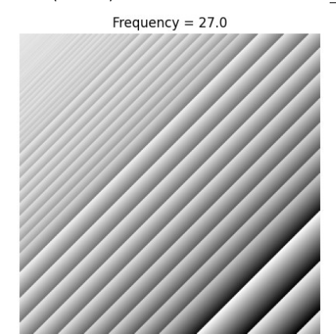
TASK#2:
For the image given below (provided with the lab handout), apply the connectected component labelling and count the total number of colored objects.
CODE:
import cv2
import numpy as np
import matplotlib.pyplot as plt
# Load the image
image_path = '/mnt/data/Screenshot 2024-10-10 211625.jpg'
image = cv2.imread(image_path)
# Convert to grayscale
gray = cv2.cvtColor(image, cv2.COLOR_BGR2GRAY)
# Apply thresholding to create a binary image
_, binary = cv2.threshold(gray, 1, 255, cv2.THRESH_BINARY)
# Apply connected component analysis
num_labels, labels = cv2.connectedComponents(binary)
# Display the result
plt.figure(figsize=(10,10))
plt.imshow(labels, cmap='nipy_spectral')
plt.title(f'Total Colored Objects: {num_labels - 1}') # Subtract 1 to
exclude the background
plt.show()
# Print the total number of objects
print(f'Total number of colored objects: {num_labels - 1}') # Exclude
background
OUTPUT:
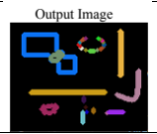
TASK#3:
First convert image given below in gray scale and threshold the images and then do connected component analysis. (Do this using build-in commands)
CODE:
import cv2
import matplotlib.pyplot as plt
# Load the image with double backslashes for the Windows path
image = cv2.imread('D:\\BSCOMPUTER ENGINEERING\\4th
YEAR OF COMPUTER ENGINEERING\\7th
SEMESTER\\DIGITAL IMAGE PROCESSING\\PROGRAMS OF
DIGITAL IMAGE PROCESSING\\Screenshot 2024-10-16
192325.jpg')
# Check if the image is loaded properly
if image is None:
print("Error: Could not load the image. Check the path.")
else:
# Convert image to grayscale
gray_image = cv2.cvtColor(image, cv2.COLOR_BGR2GRAY)
# Apply thresholding (binary threshold)
_, thresholded_image = cv2.threshold(gray_image, 127, 255,
cv2.THRESH_BINARY)
# Perform connected components analysis
num_labels, labels_im =
cv2.connectedComponents(thresholded_image)
# Display the results
plt.figure(figsize=(10, 5))
plt.subplot(1, 3, 1)
plt.title("Original Image")
plt.imshow(cv2.cvtColor(image, cv2.COLOR_BGR2RGB))
plt.subplot(1, 3, 2)
plt.title("Grayscale Image")
plt.imshow(gray_image, cmap='gray')
plt.subplot(1, 3, 3)
plt.title("Thresholded Image with Connected Components")
plt.imshow(labels_im, cmap='nipy_spectral')
plt.show()
print(f'Number of connected components: {num_labels}')
OUTPUT:
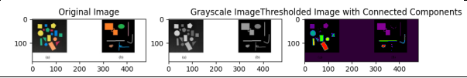

Experiment # 04
Implementation of Gray Level Transformation
TASK#1:
Contrast stretching is a simple image enhancement technique that attempts to improve the contrast in an image by `stretching' the range of intensity values it contains to span a desired range of values. Normally (min, max) → (0, 255)
CODE:
import cv2
import numpy as np
import matplotlib.pyplot as plt
# Load the image in grayscale
image = cv2.imread('Screenshot 2024-10-26 114803.jpeg', 0)
r_min, r_max = np.min(image), np.max(image)
contrast_stretched = (image - r_min) * (255 / (r_max - r_min))
# Normalize to [0, 255]
contrast_stretched = np.array(contrast_stretched, dtype=np.uint8)
plt.subplot(1, 2, 1)
plt.title('Original Image')
plt.imshow(image, cmap='gray')
# Display the result
plt.subplot(1, 2, 2)
plt.imshow(contrast_stretched, cmap='gray')
plt.title('Contrast Stretching')
plt.tight_layout()
plt.show()
OUTPUT:
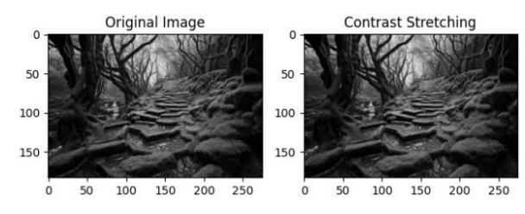
TASK#2:
Thresholding is the operation through which an image can be
converted into a binary image/black & white i.e. having only two
distinct levels. Threshold value can be the mean or median etc. of the
image. Each pixel is compared to a threshold value:
• Pixels greater than the threshold are set to one value (e.g., 255).
• Pixels below the threshold are set to another value (e.g., 0).
CODE:
import cv2
import numpy as np
import matplotlib.pyplot as plt
# Load the image in grayscale
image = cv2.imread('Screenshot 2024-10-26 122352.jpeg', 0)
# Apply simple thresholding
# Threshold at 127, values above 127 are set to 255, below are set to 0
_, binary_image = cv2.threshold(image, 127, 255,
cv2.THRESH_BINARY)
# Apply inverse binary thresholding
_, binary_inv_image = cv2.threshold(image, 127, 255,
cv2.THRESH_BINARY_INV)
# Display original and thresholded images
plt.figure(figsize=(10, 5))
plt.subplot(1, 3, 1)
plt.imshow(image, cmap='gray')
plt.title('Original Image')
plt.axis('off')
plt.subplot(1, 3, 2)
plt.imshow(binary_image, cmap='gray')
plt.title('Binary Thresholding')
plt.axis('off')
plt.subplot(1, 3, 3)
plt.imshow(binary_inv_image, cmap='gray')
plt.title('Inverse Binary Thresholding')
plt.axis('off')
plt.tight_layout()
plt.show()
OUTPUT:
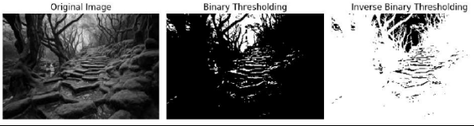
TASK#3:
Gray level Slicing is used to highlight a specific range of gray levels in an image.
It can either:
Highlight a specific intensity range while keeping other intensities intact.
Highlight a specific intensity range while suppressing all other intensities to black (0).
CODE:
import cv2
import numpy as np
import matplotlib.pyplot as plt
# Load the image in grayscale
image = cv2.imread('Screenshot 2024-10-26 122930.png',
cv2.IMREAD_GRAYSCALE)
# Define the gray-level slicing function
def gray_level_slicing(image, min_val, max_val, slice_value):
# Create an output image filled with zeros (black)
output_image = np.zeros_like(image)
# Set the pixel values within the specified range to the slice_value
output_image[(image >= min_val) & (image <= max_val)] =
slice_value
return output_image
# Apply gray-level slicing to highlight pixels in the range [100, 200]
sliced_image = gray_level_slicing(image, 100, 200, 255)
# Display original and gray-level sliced images
plt.figure(figsize=(10, 5))
plt.subplot(1, 2, 1)
plt.imshow(image, cmap='gray')
plt.title('Original Image')
plt.axis('off')
plt.subplot(1, 2, 2)
plt.imshow(sliced_image, cmap='gray')
plt.title('Gray Level Slicing')
plt.axis('off')
plt.tight_layout()
plt.show()
OUTPUT:
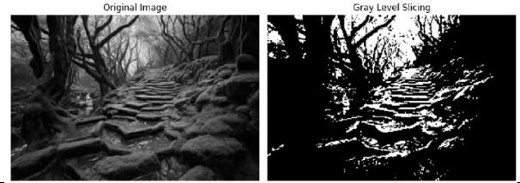
TASK#4:
Transformation operations help enhance the quality of the image by
applying operations like log, inverse log and power on the entire image.
Different type of transformation yields different results.
1. Power-Law (Gamma) Transformation:
Gamma correction is used for adjusting brightness. The formula of
power or gamma transformation is:
S=c.ry
where c and gamma are constant.
CODE:
import cv2
import numpy as np
import matplotlib.pyplot as plt
def gamma_correction(image, gamma):
# Normalize the image to range [0, 1]
normalized_image = image / 255.0
# Apply the gamma correction
gamma_corrected = np.power(normalized_image, gamma)
# Scale back to [0, 255]
gamma_corrected = np.uint8(gamma_corrected * 255)
return gamma_corrected
# Load the image in grayscale
image = cv2.imread('download.jpeg', 0)
# Define different gamma values for experimentation
gamma_values = [0.5, 1.0, 1.5, 2.0]
# Plot original and gamma corrected images
plt.figure(figsize=(12, 8))
# Display original image
plt.subplot(2, 3, 1)
plt.imshow(image, cmap='gray')
plt.title('Original Image')
plt.axis('off')
# Apply Gamma Transformations for each gamma value
for i, gamma in enumerate(gamma_values):
gamma_image = gamma_correction(image, gamma)
# Display the gamma corrected image
plt.subplot(2, 3, i + 2)
plt.imshow(gamma_image, cmap='gray')
plt.title(f'Gamma = {gamma}')
plt.axis('off')
plt.tight_layout()
plt.show()
OUTPUT:
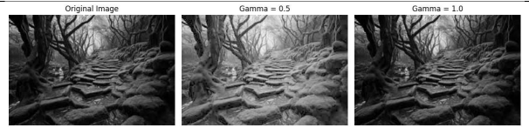
TASK#5:
Log transformation enhances darker pixels in an image. The formula
of log transformation is:
s=c*log(1+r)
where c is a scaling constant and r is the pixel intensity.
c = 255 / log(1 + rmax )
CODE:
import cv2
import numpy as np
import matplotlib.pyplot as plt
# Load the image in grayscale
image = cv2.imread('download.jpeg', 0)
c = 255 / np.log(1 + np.max(image))
log_transformed = c * (np.log(1 + image))
# Normalize to [0, 255]
log_transformed = np.array(log_transformed, dtype=np.uint8)
# Display the result
plt.subplot(1, 2, 1)
plt.title('Original Image')
plt.imshow(image, cmap='gray')
plt.subplot(1, 2, 2)
plt.imshow(log_transformed, cmap='gray')
plt.title('Log Transformation')
plt.tight_layout()
plt.show()
OUTPUT:
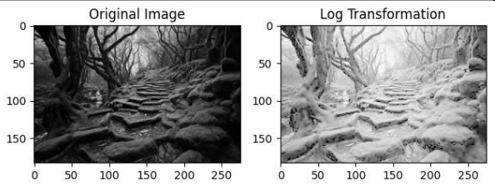
TASK#6:
Image Negative:
This technique inverts the intensity of pixels. The formula for inverse
transformation is:
s=(L-1)-r
where L is the maximum pixel value, typically 256 for 8-bit images.
CODE:
import cv2
import numpy as np
import matplotlib.pyplot as plt
# Load the image in grayscale
image = cv2.imread('download.jpeg', 0)
# Perform negative transformation
negative_image1 = 255 - image
# Perform negative operation using cv2.bitwise_not()
negative_image2 = cv2.bitwise_not(image)
# Display original and negative image
plt.subplot(3, 1, 1)
plt.title('Original Image')
plt.imshow(image, cmap='gray')
plt.subplot(3, 1, 2)
plt.title('Negative Image After subtracting from L=255')
plt.imshow(negative_image1, cmap='gray')
plt.subplot(3, 1, 3)
plt.title('Negative Image using cv2.bitwise_not()')
plt.imshow(negative_image2, cmap='gray')
plt.tight_layout()
plt.show()
OUTPUT:
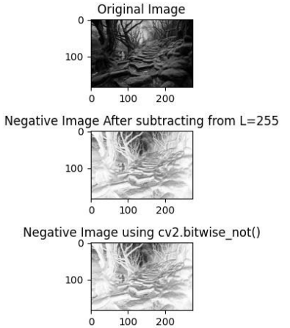
TASK#7:
Apply contrast stretching on the image provided in lab by setting 5th and 95th percentiles of the input values to 0 and 255 respectively.
CODE:
import cv2
import numpy as np
import matplotlib.pyplot as plt
# Load the image
img = cv2.imread('Screenshot 2024-10-26 122930.jpg', 0)
# Calculate the 5th and 95th percentiles
p5 = np.percentile(img, 5)
p95 = np.percentile(img, 95)
# Apply contrast stretching
stretched_img = np.clip((img - p5) * (255 / (p95 - p5)), 0,
255).astype(np.uint8)
# Display the original and stretched images
plt.figure(figsize=(10, 5))
plt.subplot(1, 2, 1)
plt.imshow(img, cmap='gray')
plt.title('Original Image')
plt.axis('off')
plt.subplot(1, 2, 2)
plt.imshow(stretched_img, cmap='gray')
plt.title('Contrast Stretched Image')
plt.axis('off')
plt.tight_layout()
plt.show()
OUTPUT:
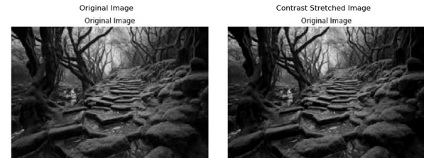
TASK#8:
Apply the following transformation on an contrast enhanced image.
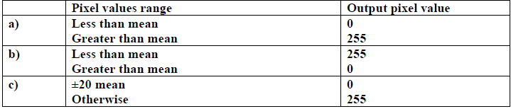
CODE:
import cv2
import numpy as np
# Load the image
image = cv2.imread('Screenshot 2024-10-26 200104.jpg',
cv2.IMREAD_GRAYSCALE)
# Enhance contrast
enhanced_image = cv2.equalizeHist(image)
# Calculate the mean pixel value
mean = np.mean(enhanced_image)
# Apply the transformation
# Option a)
transformed_image_a = np.where(enhanced_image < mean, 0,
255).astype(np.uint8)
# Option b)
transformed_image_b = np.where(enhanced_image < mean, 255,
0).astype(np.uint8)
# Option c)
transformed_image_c = np.where(np.abs(enhanced_image - mean) <=
20, 0, 255).astype(np.uint8)
# Display the results
cv2.imshow('Original Image', image)
cv2.imshow('Enhanced Image', enhanced_image)
cv2.imshow('Transformed Image (Option a)', transformed_image_a)
cv2.imshow('Transformed Image (Option b)', transformed_image_b)
cv2.imshow('Transformed Image (Option c)', transformed_image_c)
cv2.waitKey(0)
cv2.destroyAllWindows()
OUTPUT:
TASK#9:
After obtaining constrast streatched images from task 1 .Apply Power Law transformation for the following values of γ (0.2,0.5, 1.2 and 1.8) . Make sure to adjust data types accordingly.
CODE:
import cv2
import numpy as np
# Load the image
img = cv2.imread('Screenshot 2024-10-26 200104.jpg',
cv2.IMREAD_GRAYSCALE)
# Define the gamma values
gamma_values = [0.2, 0.5, 1.2, 1.8]
# Apply Power Law transformation for each gamma value
for gamma in gamma_values:
# Convert image to float type
img_float = img.astype(np.float32) / 255.0
# Apply Power Law transformation
img_gamma = np.power(img_float, gamma)
# Convert image back to uint8 type
img_gamma = (img_gamma * 255.0).astype(np.uint8)
# Display the image
cv2.imshow(f'Gamma: {gamma}', img_gamma)
cv2.waitKey(0)
# Close all windows
cv2.destroyAllWindows()
OUTPUT:
Experiment # 05
Implementation of Image Histogram and Equalization
TASK#1:
An image histogram is a visual representation of the tonal distribution in a digital image, plotting the number of pixels for each tonal value, allowing viewers to quickly understand the entire tonal distribution in a specific image.
CODE:
import cv2
import numpy as np
import matplotlib.pyplot as plt
# Load the image in grayscale
image = cv2.imread('download.jpeg', 0)
# Calculate the histogram using numpy.histogram()
# 'bins=256' means we want 256 intensity levels (for grayscale images,
0 to 255)
# 'range=(0, 256)' means we are considering pixel intensities in this
range
hist, bin_edges = np.histogram(image, bins=256, range=(0, 256))
#histogram = cv2.calcHist([image], [0], None, [256], [0, 256])
# Plot the histogram
plt.plot(bin_edges[0:-1], hist)
plt.title('Image Histogram')
plt.xlabel('Pixel Intensity')
plt.ylabel('Frequency')
plt.show()
OUTPUT:
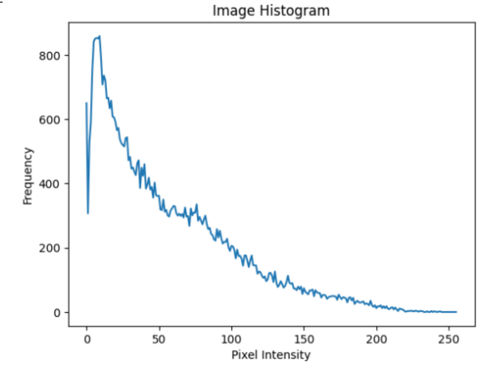
TASK#2:
Histogram equalization:
Histogram of an image shows the frequency of different intensities values present in the image. This gives a clear idea of what intensities dominate the image. Histogram equalization is a technique that uses this information to enhance the contrast using the probability of a certain pixel to occur. The Image obtained will be Histogram Equalized Image with high contrast.
CODE:
import cv2
import numpy as np
import matplotlib.pyplot as plt
# Load the image in grayscale
image = cv2.imread('download.jpeg', 0)
# Perform Histogram Equalization
equalized_image = cv2.equalizeHist(image)
# Calculate the histogram of the equalized image
equalized_histogram = cv2.calcHist([equalized_image], [0], None,
[256], [0,
256])
# Display the original and equalized image side by side
plt.subplot(2, 2, 1)
plt.imshow(image, cmap='gray')
plt.title('Original Image')
plt.subplot(2, 2, 2)
plt.plot('histogram')
plt.title('Original Histogram')
plt.subplot(2, 2, 3)
plt.imshow(equalized_image, cmap='gray')
plt.title('Equalized Image')
plt.subplot(2, 2, 4)
plt.plot(equalized_histogram)
plt.title('Equalized Histogram')
plt.show()
OUTPUT:
